Year 2 Homework – Autumn Term 2
Choose an activity to complete for homework from each section. Please bring your homework book back into school by Monday 12th December.
Children can either carry out the tasks using the templates set on Purple Mash or they can use their homework book.
Vocabulary
- Log into Purple Mash and write about what you can see in each season of the year. What happens to the trees/plants/animals and weather?
- Log into Purple Mash and write a range of sentences using different words for ‘walk’. For example, I stride quickly to school because I don’t want to be late. The soldiers marched in the parade.
- Come up with a list of words which mean the same as: - said/ went/ good. Use a thesaurus to help you e.g. said
        - shouted
        - yelled
        - whispered
Read & Respond
- Read about the explorer Amelia Earhart on https://kids.nationalgeographic.com/explore/history/amelia-earhart/ Then write about something you would like to achieve in the future. There is a template on Purple Mash.
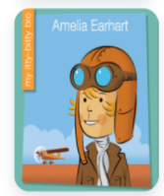
- Read the start of any book and then make a prediction about what might happen next in the story.
- Draw a picture of your favourite fictional character and write about what they look like and their personality. There is a template for you to complete this on Purple Mash.

Creativity
- Make a model of Neil Armstrong’s space rocket using a bottle or cardboard tube.
- Design a seasonal greetings card using printing
- Log into Purple Mash and draw pictures of how the trees look in each season.
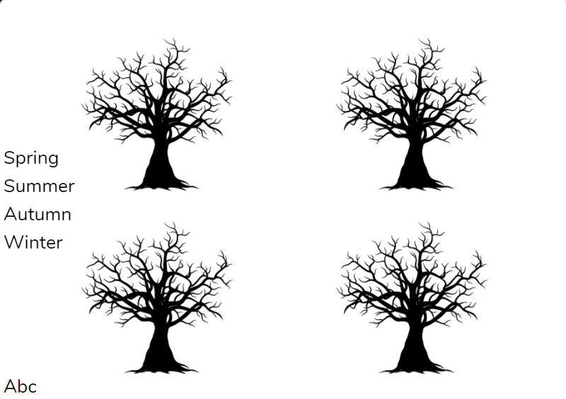
Family
- Interview an older member of the family about the moon landing in 1969. Write some questions for them to answer.
- With an adult, practise your counting in multiples of 2’s, 5’s and 10’s by counting 2p, 5p and 10p coins.
- Follow some instructions to do seasonal themed baking with an adult.

