Year 2 Homework – Autumn Term 1
Please choose one activity to complete for homework from each section. You will need to complete this half term’s homework by Wednesday 19th October 2022. A lot of the tasks we have set are on Purple Mash (log ins are in the front of the green reading diaries) and children will receive feedback via this platform. Other work can be sent into school in the homework book.
Certificates will be awarded for four completed pieces of homework. We will share homework in class as a celebration of our work.
English
- Copy out a section of a book in your best cursive handwriting
- Choose an animal from one of the continents we’ve been studying. List five adjectives to describe the animal e.g. scary, tall, small etc. You can either do this in your book or using the template we have set on Purple Mash
- Read your school reading books at home at least three times a week and make sure your parent/guardian signs the reading diary.
- Log into Purple Mash and there are some spelling quizzes to complete.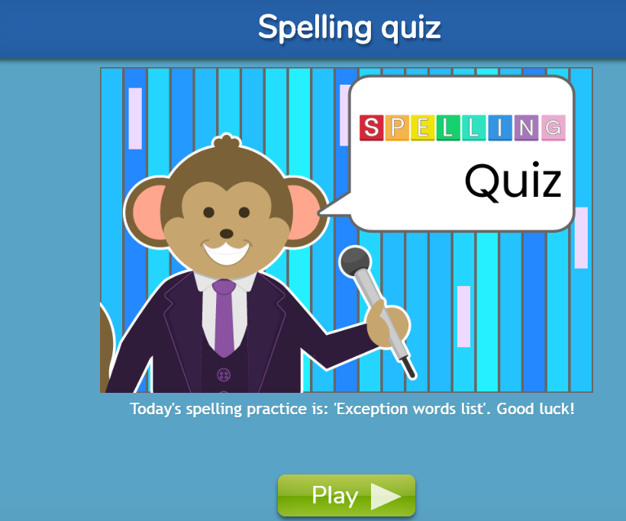
Maths
- To write the numbers from 1 to 100 correctly, making sure there are no reversals.
- Visit the website https://www.topmarks.co.uk/maths-games/hit-the-button Here you can practise number bonds to 10 and 20, also doubles up to 10 and halves up to 20. Try to get a quick recall of these number facts.
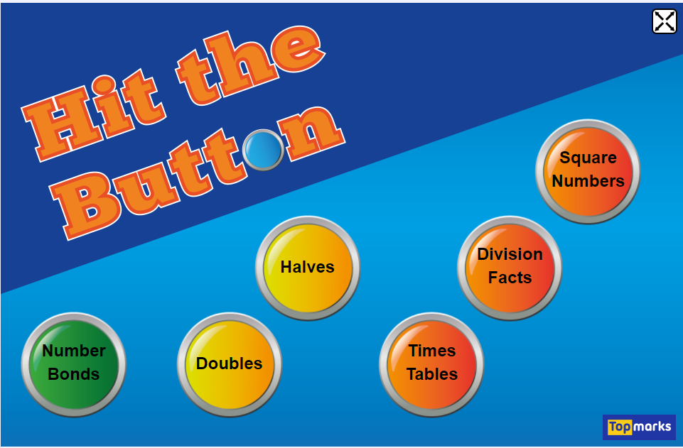
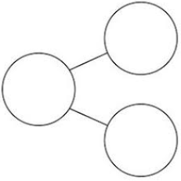
- Ask a grown up to write a list of two digit numbers then partition them in a variety of ways e.g.
46
46
46

40
6
26
20
36
10

Topic
- Log into Purple Mash and we have set you two tasks, to label different countries and continents.
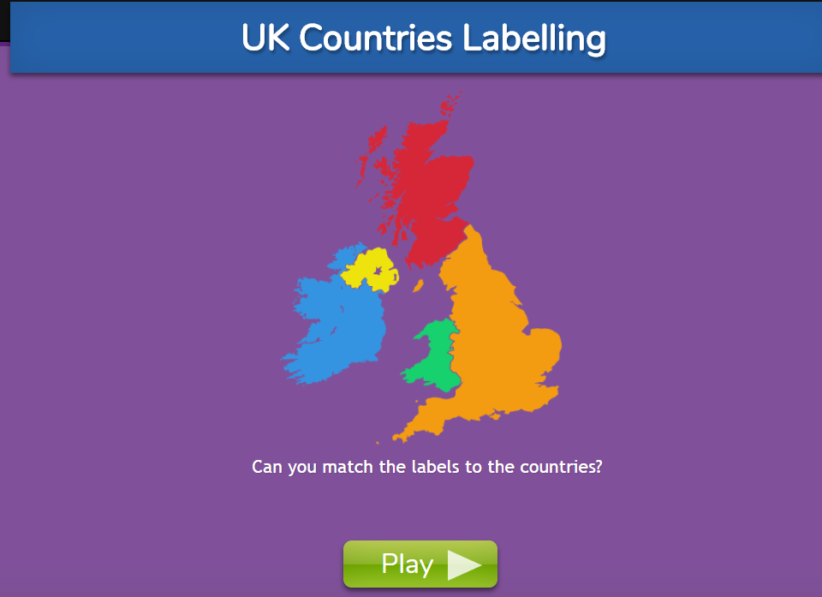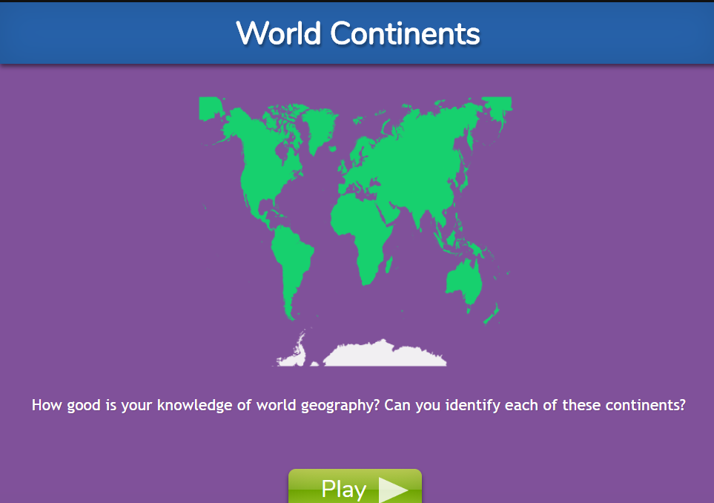
- Research one of the continents and write some sentences about it e.g. landmarks, foods, animals, weather etc. We have set you a template which you can use on Purple Mash or you can do a paper version in your book

- Create a portrait of a member of your family. You can either use the paint program on Purple Mash (we have set this as a 2do) or you can do a paper version in your book.
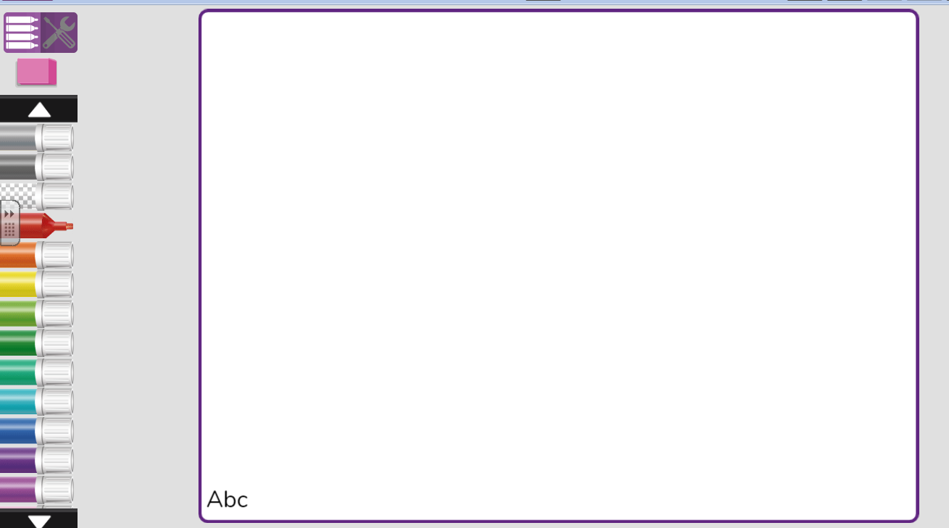

Family/Home
- Play a board game or card game with your family.
- Design a healthy snack/meal with an adult and make it together. There is a template on Purple Mash where you can design your own healthy plate of food.
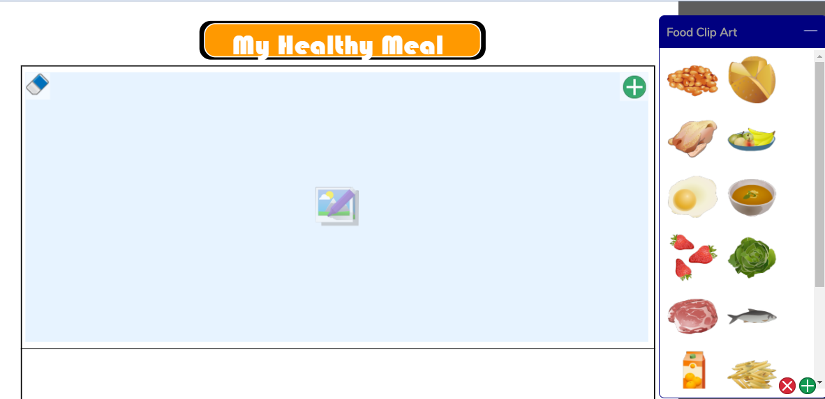
- Go for a walk and look for signs of Autumn.

