Year 2 Homework – Autumn Term 2
Choose an activity to complete for homework from each section. Please bring your homework book back into school by Monday 13th December 2024
Vocabulary
- Write about what you can see in each season of the year. What happens to the trees/plants/animals and weather?
- Write a range of sentences using different words for ‘walk’. For example;- The soldiers marched in the parade.
- Come up with a list of words which mean the same as: - said/ went/ good. Use a thesaurus to help you e.g. said
        - shouted
        - yelled
        - whispered
Read & Respond
- Read about the explorer Amelia Earhart on https://kids.nationalgeographic.com/explore/history/amelia-earhart/ Then write about something you would like to achieve in the future.
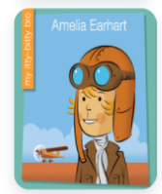
- Read the start of any book and then make a prediction about what might happen next in the story.
- Draw a picture of your favourite fictional character and write about what they look like and their personality.

Creativity
- Make a model of Neil Armstrong’s space rocket using a bottle or cardboard tube.
- Design a seasonal greetings card using printing
- Log into Purple Mash and draw pictures of how the trees look in each season.
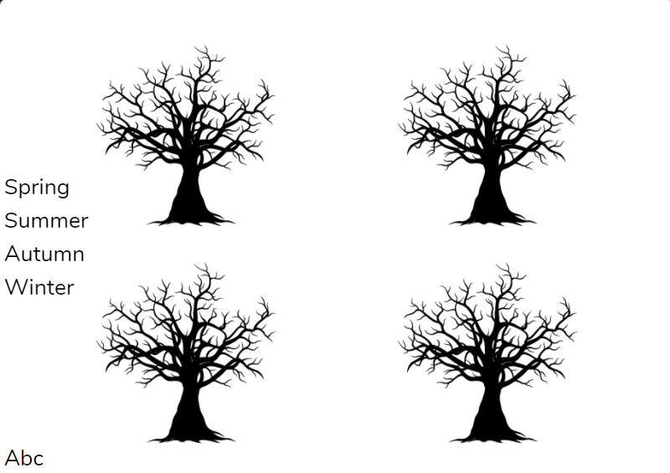
Family
- Interview an older member of the family about the moon landing in 1969. Write some questions for them to answer.
- With an adult, practise your counting in multiples of 2’s, 5’s and 10’s by counting 2p, 5p and 10p coins.
- Follow some instructions to do seasonal themed baking with an adult.

