Year 2 Homework – Autumn Term 1
Please choose one activity to complete for homework from each section. You will need to complete this half term’s homework by Tuesday 15th October 2024
English
- Copy out a section of a book in your best cursive handwriting
- Read your school reading books at home at least three times a week and make sure your parent/guardian signs the reading diary.
- Log into Purple Mash (log in details are at the front of your green reading diary) and there are some spelling quizzes to complete.
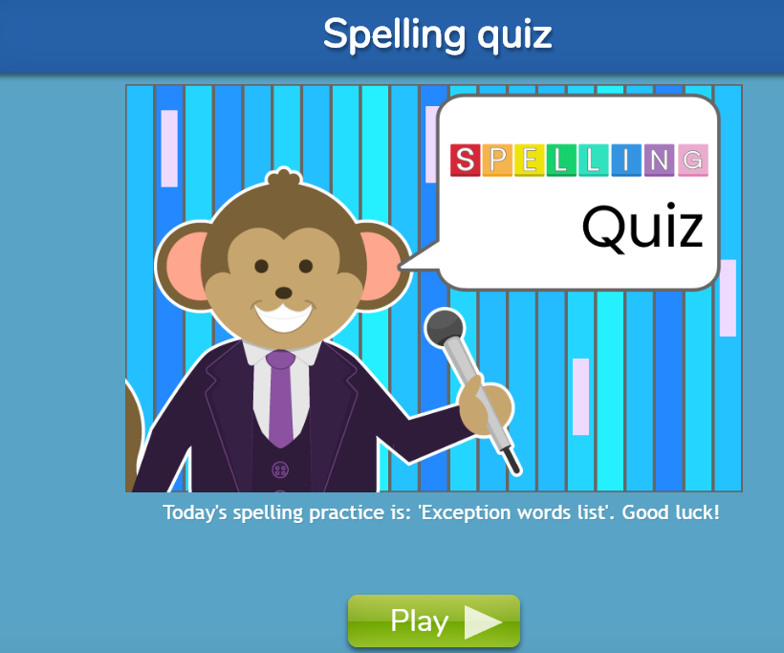
Maths
- To write the numbers from 1 to 100 correctly, making sure there are no reversals.
- Visit the website https://www.topmarks.co.uk/maths-games/hit-the-button Here you can practise number bonds to 10 and 20, also doubles up to 10 and halves up to 20. Try to get a quick recall of these number facts.
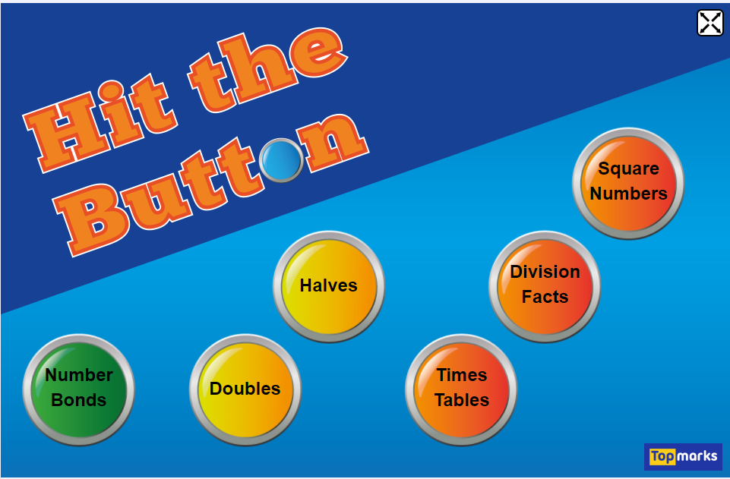
- Ask a grown up to write a list of two digit numbers then partition them in a variety of ways e.g.

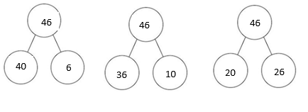

Topic
- Create a portrait of a member of your family.
- Research baby animal names e.g. foal, gosling, kid etc and draw pictures of them in your book.
- Have a go at balancing on different parts of your body and see if you can do a pencil roll, egg roll, dish roll and a teddy bear roll. Put them together in a sequence that we can show in our gymnastics lesson.
- We are learning about ways to be kind in school. Make a poster showing different ways we can be kind to others.

